**PERIOD: 14 REVISION**

**“TAG QUESTIONS, GERUND AFTER VERBS”**

**1. Tag Questions *(Câu hỏi đuôi)***

|  |  |
| --- | --- |
| **PHẦN ĐẦU** | **PHẦN ĐUÔI** |
| Khẳng định (+) | Phủ định (-) |
| Ex: Jane often **drinks** coffee in the evening, **doesn’t she** ? | |
| Phủ định (-) | Khẳng định (+) |
| Ex: This book **isn’t** interesting, **is it**? | |

*Note:

1. Không dùng danh từ riêng trong câu hỏi đuôi , mà phải dùng đại từ nhân xưng thay thế

Eg: Mary is beautiful, **isn’t she** ?

2.

S = these, thoses, nobody, anybody, somebody,everybody, someone…

=> câu hỏi đuôi là they

S = this, that, nothing, something, anything,everything,..

=> câu hỏi đuôi là it

3.

Nếu câu có các từ phủ định: neither, no, no one, nobody, nothing, hardly, seldom,never, no longer, scarely, barely……, thì câu hỏi đuôi dùng khẳng định.

Eg: Nobody likes snakes, **do they** ?

**\* DẠNG ĐẶC BIỆT:**

✓ I am …, aren’t I?

✓ Let’s …, shall we?

✓ S + used to V1, didn’t +S?

✓ S + ought to…….., shouldn’t…….?

✓ S + had better/’d better, hadn’t +S?

✓ S + would rather / ‘d rather … , wouldn’t + S ?

✓ S + have to / has to / had to + V1 … , don’t / doesn’t / didn’t + S ?

✓ Yêu cầu, đề nghị : V + O…., will you?

Don’t + V….,.

✓ Lời mời, won’t you?

✓ I wish……………, may I ?

**\*EXERCISES**

**EXERCISE 1:Complete the dialogues with the correct tag**

a) Jim: You have read this article on the website,…………………?

Lina: Not, yet

b) Minh: Baird produced the first TV picture in 1926, ………………?

Thao: Yes, he did

c) Thu: A daily newspaper was published in Germany in 1550,…………..?

Tri: No, it wasn’t. It was in 1650

d) Ha: You don’t like playing computer games,………………?

Thanh: Yes, I do. But I don’t have much time for it.

e) Mai: We are going to have cable TV soon,……………..?

Thang: Yes, I think so.

**EXERCISE 2: Complete the questions by adding the tag questions:**

1. It’s a lovely day,_______________________?

2. Tom drives very fast,_________________________?

3. She wrote the poem herself, __________________?

4. That was exciting,_______________________?

5. You couldn’t lend me $ 5, __________________?

7. He’d rather go to the theatre,______________?

8. They had better attend the meeting,_________________?

9. They hadn’t been there before,__________________________?

10. She had to complain to the manager,______________________?

11. Nick wouldn't tell anyone about this story, __________?

12. He hardly ever leaves the house,__________________________?

1. Your central heating doesn’t work very well,_________________?
2. Jack’s applied for the job,____________________?

15. You can type,_________________?

**3. EXERCISE 3: Complete the questions by adding the tag questions:**

1. He hardly ever makes a mistake, _______ ?

2. Nobody likes the play, _______ ?

3. I don’t suppose there is anyone there, ______ ?

4. This is your pen, _______ ?

5. Somebody wanted a drink, _______ ?

6. Let’s go for a swim,_________________?

7. He used to live here, _______ ?

8. Those aren’t your books, _______ ?

9. Neither of them offered to help you_______ ?

10. Nothing went wrong yesterday, ___________ ?

11. I’m too fat,____________________?

12. Don’t drop it,_________________________?

13. I wish to shake hands with you, ______?

14. This won’t take long, _______ ?

15. It never works very well, _______ ?

**EXERCISE 4: Rewrite the sentences using tag questions**

1. Are you a writer?

🡪 You are ____________________________________?

2. Does he cook dinner every night?

🡪 He ___________________________________________?

3. Has Tom never seen this movie before ?

🡪 Tom has ___________________________________________?

4. Did they wash their car yesterday ?

🡪 Their car ___________________________________________?

5. Is Mary reading newspaper?

🡪Mary ___________________________________________?

**2. Gerunds after some verbs**

**\* Các động từ theo sau là V-ing**

|  |  |  |
| --- | --- | --- |
| Admit: nhận, chấp nhận  Avoid: tránh  Advise: khuyên  Appreciate: đánh giá cao  Can’t bear  Can't help Không Chịu Nổi  Can’t stand  Carry on = go on: tiếp tục  Complete: hoàn tất  Consider: suy nghĩ, xem xét  Delay = postpone = put off: trì hoãn | Deny: từ chối  Detest: ghét  Discuss: thảo luận  Dislike: không thích  Enjoy: thích  Finish: kết thúc  Forgive: tha thứ  Give up: từ bỏ  Hate: gét  Keep (on): giữ, cứ tiếp tục  Love: yêu, thương | Mention: đề cập  Miss: bỏ lỡ  Mind : phiền lòng  Practice: luyện tập  Recall: nhớ lại  Recommend = Propose: đề xuất  Resent: tức giận  Resist: từ chối  Risk: có nguy cơ  Suggest: gợi ý  Try: thử (quần áo, thức ăn) |

|  |  |  |
| --- | --- | --- |
| Be busy: bận rộn  Have fun / a good time: tận hưởng  be/get used to =  be/get accustomed to : quen với ..  It’s no use  = It’s no good: chẳng lợi ích gì  Waste time: lãng phí thời gian  Be worth: đáng | Spend time: dành thời gian  Look forward to: mong đợi  Object to: phản đối  Go boating: đi chèo thuyền  Go fishing: đi câu cá  Go hunting: đi săn  Go sailing: đi lái thuyền  Go swimming: đi bơi | Go camping: đi cắm trại  Go hiking: đi bộ đường dài  Go mountain climbing: đi leo núi  Go shopping: đi mua sắm  Go sightseeing: đi thăm quan  Go skating: đi trượt băng  Go skiing: đi trượt tuyết |

**EXERCISE 5: Complete each sentences with one of these verbs**

**write turn listen play wait**

1. I enjoy _____________to music.

2. Do you like ______________soccer?- yes,I do.

3. Would you mind ___________the radio down?

4. My brother hates _____________ letters.

5. I dislike _____________in line at the grocery store.

**EXERCISE 6: Choose the best answer**

1. I couldn't help _________ when he tripped!

to laugh B. to laughing C. laughing D. laugh

2. Would you mind _________ the window ? It's very hot in here.

A. to open B. to opening C. open D. opening

3. Since coming here, I've got used to_________ to bed early.

A. to going B. going C. go D. to go

4. Do you often practise _________ English?

A. speaking B. to speak C. speak D. spoke

5. I must remind my students that this grammar point needs _________

A. revise B. revising C. to revise D. revised

6. I finally finished at 7.00pm and served dinner .

A. cooking B. being cooked C . to cook D.to be cooked

7. Quang continued ___________ to the city center.

A. drive B. to have been driving C. to drive D. to driving

8. Yoko tried ___________the bus , but he missed it.

A. catch up B. catch C. to catch D. catching

9. Vietnamese women today often prefer _________ mordern clothing at work , because it is more convinient.

A. wear B. wore C. wears D.to wear

10. They make their living by__________fish in the river.

A. catch B. to catch C. catching D. caught

**\*Homework:**

**Write true sentences about your parents, siblings, relatives, friends and yourself.**

Example:

***My father likes watching sports but my mother doesn’t. She loves listening to music****.*

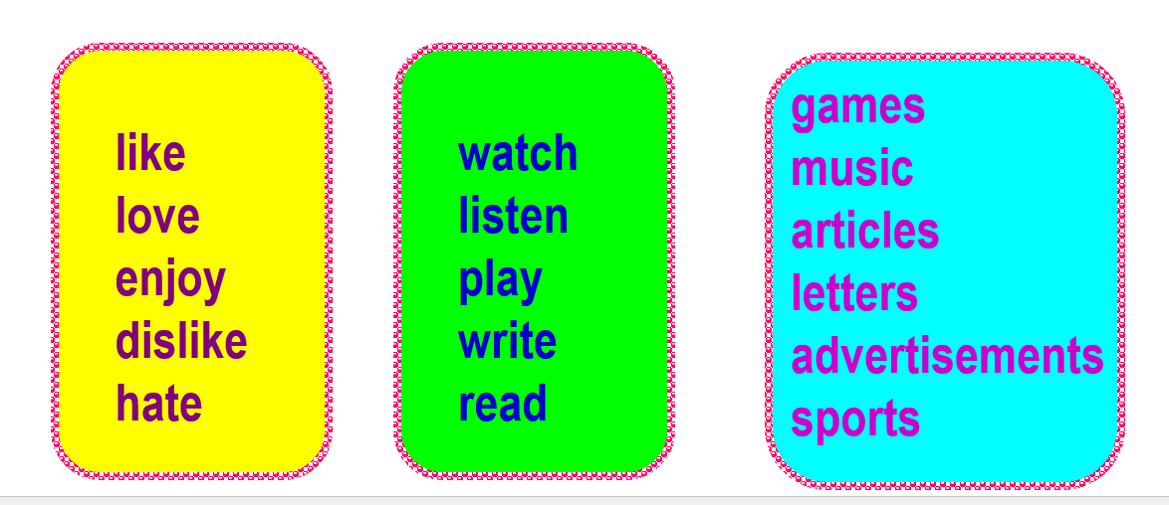

**PERIOD 28**

**THEME 4: FOLK TALES AND LEGENDS**

**LESSON 1**

**I. New words**

1. scream (v) /skriːm/ : thét lên

2. wolf (v) /dɪˈliːt/ : chó sói

3. forest (v) /pres/ : rừng

4. axe (n) /ˈdesktɒp/ : cái rìu

5. hood (v) /ˈkɒpi/ : mũ trùm đầu

6. cottage (v) /peɪst/ : nhà tranh

7. fall – fell - fallen (v) : té, ngã

8. steal – stole - stolen(v) : trộm, cắp

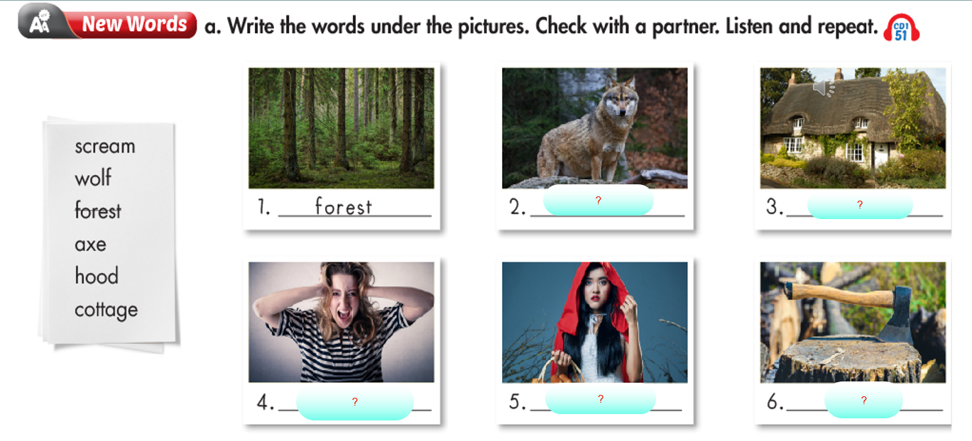**\*Open your book on page 34 and do this exercise:**

**II. Grammar**

**2**

**4**

**3**

?

?

?

**The Past Simple tense and the Past Continuous tense**

**1. Past Simple**

Action that was completed in the past:

*Tom* ***went*** *fishing last week.*

*I* ***worked*** *until 2:00 p.m. yesterday.*

*My family* ***came*** *to visit me last year.*

*Time Expressions frequently used with Past Simple:

yesterday, last ______, past dates (in 1990), _____ ago, etc.

**2. Past Continuous**

Action that was in progress at a particular point in the past:

*At 2:00 yesterday, Tom* ***was playing*** *soccer.*

*Sophia wasn’t home last night when I called her. I think she* ***was working.***

**3. Using both tenses together:**

Sometimes we use both **the simple past** and **the past continuous** together to mean:

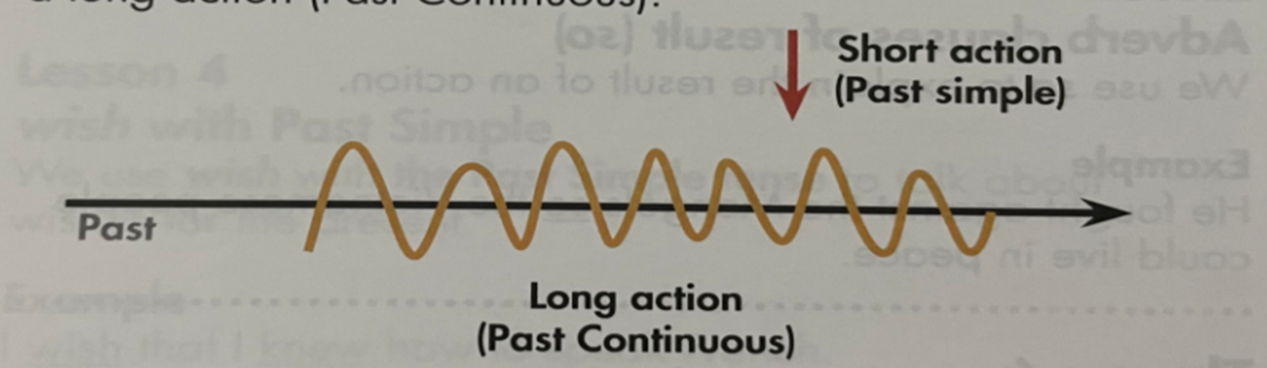That one action (simple past) ***interrupted*** a continuing action (past continuous)

**Example:**

1. Dan burned his hand as he **was cooking** dinner.

=in the middle of cooking dinner, he burned his hand.

2. When Helen called, we **were having** dinner.

=in the middle of eating dinner, Helen called.

*Note: **long action = past continuous (S + was/were+ V-ing...)**

**short action = simple past (S + V2/ed...)**

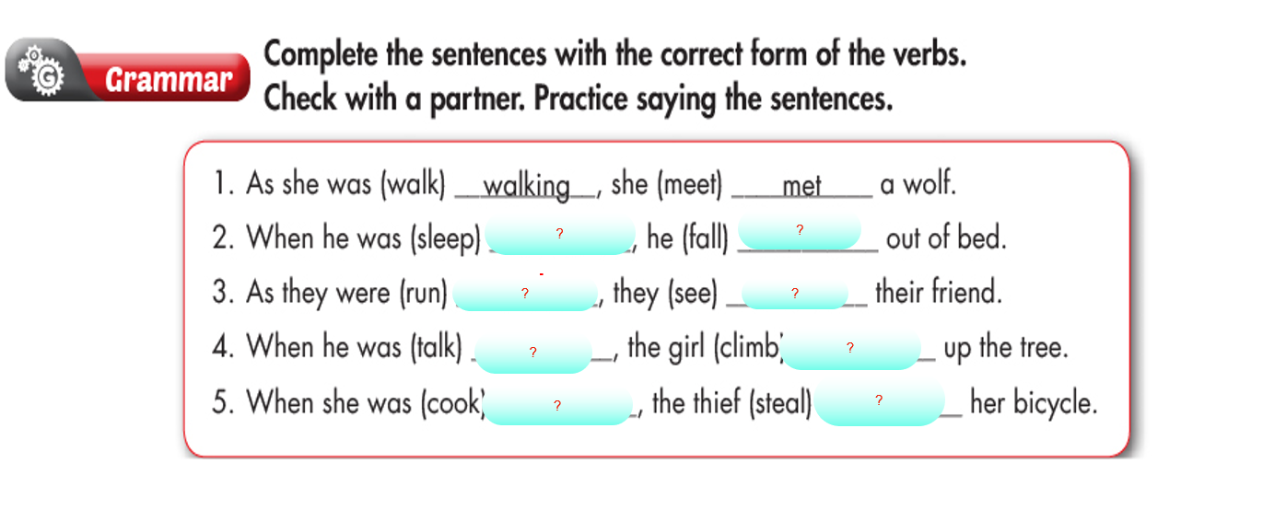**\* Open your book on page 35 and do this exercise:**

**III. Practice**

*Fill in the blanks with the correct form of the verbs:*

1. While I (sit)_________________ in a café, my mobile (ring) ___________.

2. It (start)______________ to rain while John (fish) _________________.

3. They (dance)__________________ whensuddenly the music (stop) _____________.

4. The burglar (break) ____________ into the house while they (sleep)________________.

5. He (clean)_________________ the floor when the neighbour (come)____________.

**IV. Homework**

* *Learn new words and grammar*
* *Do exercises in WB/32,33*